Naive bayes is a model for classification. Here is how it works:

Let’s assume that we have a dataset describing how much popcorn a given person eats, how much soda he drinks , how much candy he eats and if he likes a movie Troll 2. We want to predict if someone likes this movie.

Below it is shown what data do we have and distributions for columns ‘popcorn’, ‘soda’ and ‘candy’ for people who like Troll 2 and for people who don’t (we assume that those distributions are Gaussian. We need to calculate a mean and variance for each column):

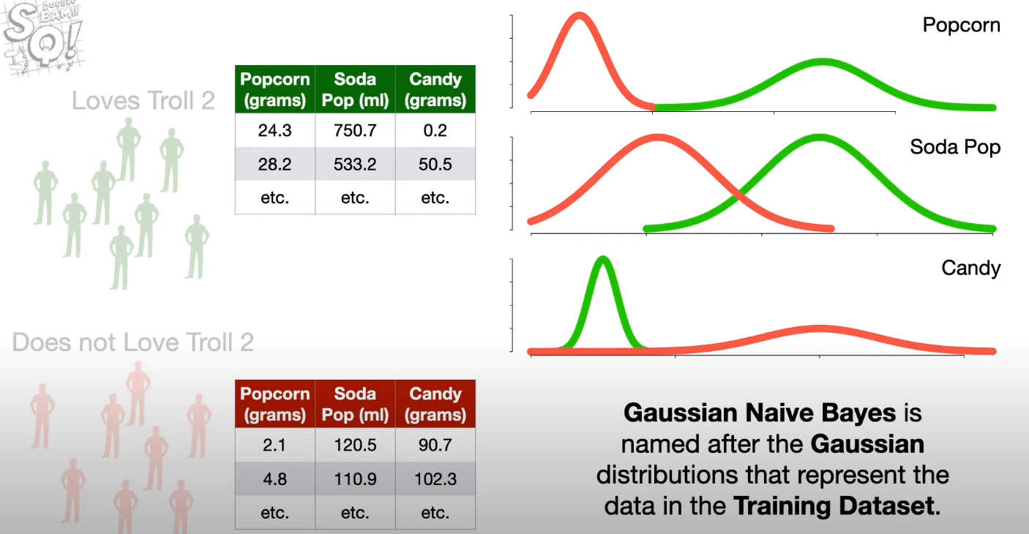

Let’s assume that a new person shows up which eats 20g of popcorn, drinks 500ml of soda and eats 25g of candy. We want to predict if this person likes a movie Troll 2.

In order to make predictions we calculate a score for that person assuming that he likes the Troll 2. We can look at this score as a ‘probability’ of observing such a person who likes this movie:

Score = log(P(likes Troll 2) * L(popcorn = 20 | likes Troll 2) * L(soda= 500 | likes Troll 2) * L(candy = 25 | likes Troll 2))

L() is a likelihood and P() is a probability.

P(likes Troll 2) = number of people who likes Troll 2 / number of all people in the dataset

To calculate likelihoods we use Gaussian distributions which we calculated earlier.

After that we calculate a score for that person assuming that he doesn’t like the Troll 2:

Score = log(P(doesn’t like Troll 2) * L(popcorn = 20 | likes Troll 2) * L(soda= 500 | likes Troll 2) * L(candy = 25 | likes Troll 2))

If this score is higher when we assume that this person likes the Troll 2 then we clasiffy this person as a person who likes the Troll 2.

